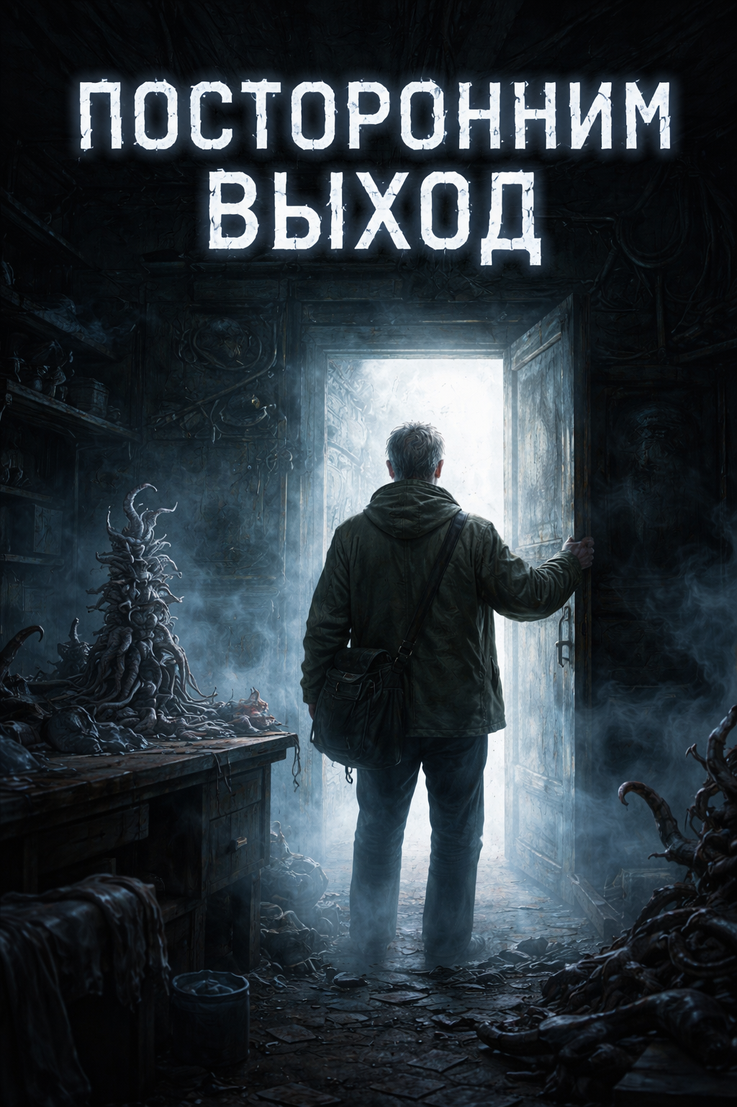

Outsiders Exit
AI translated from Russian
Finishing the last details, Lyubanov set the chisel aside and, stepping back, surveyed Creation No. 14.
A slender sculpture, about thirty centimeters tall, with the loose elegance of biomatter, loomed atop the filthy workbench. Converging toward a single point like the Monument to the Conquerors of Space and, at the same time, extending limbs in all directions like a hecatoncheires, it drew attention to its smallest fragments while completely dominating the space of the room. Although the composition consisted of many disparate elements, it stubbornly pretended to be a coherent whole and, it seemed, did not even violate the laws of spatial geometry.
“One must admit,” Lyubanov thought, wiping fresh streaks of organic components from beneath the figure, “that overall the statue looked and smelled exactly as it should. Even the vibrations it emitted were correct.”
Or was it all just his imagination?
Lately, Lyubanov had found it difficult to distinguish waking reality from sleep, and so he was not always certain of what was actually happening. In any case, it remained unclear whether it had worked or not, and how one might verify that. One thing, however, was certain: the statue needed a name. A truly special one, reflecting its uniqueness and essence.
As he continued clearing away debris, Lyubanov shuffled words, syllables, combinations in his mind, mixing associations and images: Anaform, Verium, Chaona…
And then he caught himself whispering:
“Aphrodite Cthulhu.”
It could not be said that the sculpture was feminine, like its famous namesake from Milos, or as corporeal as the Venus of Willendorf. Strictly speaking, such attributes were hardly applicable to a non-anthropomorphic figure. But it possessed an abundance of flexible tentacles and angular geometric forms, enough to harmoniously combine everything beautiful and repulsive that Lyubanov had managed to bring into it.
“A fitting name,” Lyubanov managed to think before being overtaken by the inevitable realization. “Well, of course it didn’t work. And how could it? What is special about it, really? An ordinary object of the physical world. I shouldn’t have bothered making it at all.”
Suddenly, Lyubanov felt that he had not created a statue but built yet another little tower of blocks — the flesh of the Universe itself, viscous, self-sufficient, endlessly repeating. Every line had already existed, every movement merely echoed a previous one. From matter, nothing new can be molded, only a template reproduced or an idea recalled.
“So ideas of the physical world are also embedded and predetermined from the very beginning,” Lyubanov quoted from memory with emphasis and questionable accuracy. “What we see is not true being, but only shadows and reflections of genuine essences. That’s Plato, by the way.”
“Oh for God’s sake,” Lyubanov muttered, tossing the wet rag onto a bucket of water and casting a contemptuous glance at Aphrodite. “Those ancient sages knew everything in advance. What has been will be again, and there is nothing new under the sun.”
Even though the sculpture concentrated within itself a mass of incompatible, contradictory, ambiguous, and frankly provocative elements, that alone did not make it unique. Quantity does not equal quality. These were merely elements of a proverbial construction set, little parts and blocks that humanity, with manic persistence, has been rearranging for millennia, like poor foolish Kai with his shards of ice. And I, along with them, am no better, with my fourteen creations.
Half an hour later, maneuvering like an Argonaut between Scylla and Charybdis, Lyubanov carefully passed the airy Albedo¹, skirted the bulky Absurro², and placed the fragrant but useless Aphrodite out on the balcony. Then he carefully closed the door so nothing would seep through.
Now that the new creation had been finished, rejected, and cast aside, it was time to think about what to do next. It was not that another failed experiment traumatized Lyubanov — after all, this was already the fourteenth failure since he had started counting — but after several sleepless nights of intense work, he nonetheless felt emptied. And he decided to fill that emptiness with food.
Standing in the middle of the grimy kitchen, where every stool and chair was occupied by stacks of books and albums, boxes of tools, electronic parts, and some poorly identifiable junk, the hungry Lyubanov hastily ate dumplings from the day before yesterday, washed them down with cold coffee, and narrated his inner dialogue aloud.
“So, let’s repeat the main point: it appears that in the material world it is impossible to create anything fundamentally new. Yes, perhaps in the past this might have worked, but at present it is practically impossible due to the exhaustion of available combinations.”
Lyubanov snorted.
“Maybe that’s precisely why magic, even if it once existed long ago, has completely disappeared in our time. The universal Leviathan absorbs any attempt at change, turning exceptions into rules, adapting them as laws of physics, and pretending that it was always so. Where could there possibly be room for a miracle?”
“Which leads to what?” Lyubanov raised a bitten dumpling on his fork and shook it like the standard of the Nineteenth Legion. “Exactly. We can derive the law of one-time magic: any miracle, novelty, unique event, radical shift — call it whatever you like — can occur only once. The second time, the trick won’t work, and any spell already used turns into a pumpkin.”
He shoved the rest of the dumpling into his mouth and swallowed it almost without chewing. His gaze darted across the walls, carefully avoiding forgotten paintings and photographs from the past.
“I can just imagine the faces of those magicians with their folio spellbooks! Grab it — and nothing works! And that’s even without taking Plato into account. Plato, by the way, after whom creativity in the material world has no meaning whatsoever.”
“And if that’s the case,” Lyubanov continued, shifting on the kitchen couch, “then the system must be deceived. What if the solution lies not entirely within the physical world? How material is thought? An idea? Meaning? Only the mind endows things with meaning, and information exists only while someone can transmit it and someone can receive it. Yes, all this is tightly bound to matter, and it seems that a human being cannot imagine what lies beyond their experience… But maybe they still can? Ideas are like that…”
Settling comfortably into a hollow in the bed, Lyubanov felt his thoughts dissolve into ideas, and Aristotle looked at him reproachfully, disapproving of the casual tone with which Lyubanov had quoted his teacher. Lyubanov had to apologize, explaining that in truth he was irritated and angry with himself, with his own stupidity, and that the respected Plato was of course not to blame, and he had not intended to offend him at all — quite the opposite…
Lyubanov was awakened by the doorbell.
And it was not the melodic trill produced by the polite intercom downstairs, but the hysterical rattling of a device from Soviet manufacture.
Lyubanov did not like uninvited guests, especially in the morning, or as now — half asleep. At first he tried to ignore the irritant, but the first ring was followed by a second, then a third, and then there was knocking and loud talking, indistinct through the door.
Judging by the persistence, it was neither a continuation of a dream nor part of another vision. Everything was happening for real. He had to get up.
Navigating the dimness and skirting bundles and heaps of things from a past life, Lyubanov glanced at his crumpled face in the mirror on the way to the hallway, cursed, smoothed his hair as best he could, and hastily adjusted his very domestic T-shirt and sweatpants.
“Looks like nobody’s home…” a low male voice muttered behind the door.
“He’s there, he’s there,” creaked the old woman from across the hall. “He never goes out.”
“He’s been drilling again since morning,” shrieked the housewife from apartment 42. “Only just stopped.”
They rang, knocked, and called again:
“Arkady Borisovich, are you there? Is everything alright?”
Lyubanov carefully slid aside a now unnecessary sack of dry dog food and peered through the peephole. In the corridor, besides the neighbors identifiable by voice, stood district officer Kovalev and another unidentified official figure in uniform.
Just in case, Lyubanov decided to pretend nobody was home, but he did not step away from the door and kept listening.
“That’s it,” Kovalev said, seemingly with relief. “He’s not in the apartment.”
“But it stinks!” the neighbor’s voice trembled with indignation. “It reeks! Like a slaughterhouse!”
“I don’t smell anything…”
“Maybe not here, but if you go out on the balcony…”
“Let’s go,” Kovalev nodded toward the second figure. “There’s nothing I can do.”
“We have no grounds.”
“But wait!”
“File a complaint, then we’ll deal with it…”
The sounds faded. A heavy metal door slammed downstairs. Someone ran past Lyubanov’s apartment upward. The door of apartment 42 slammed shut angrily.
Lyubanov barely suppressed a spiteful smile. They had drunk enough of his blood over the years. Then again, depending on how you look at it, perhaps it was he who had made their lives miserable with his constant experiments.
In any case, they were excellent at distraction. The moment he tried to begin work on a new creation, they immediately interfered. First, the neighbor tried to be understanding, to sympathize, to comfort him. She even once broke into the apartment.
“Maybe I can help somehow, feed you, do some laundry…”
But after she saw the workshop in all its “glory,” she immediately backed off.
“Mother of God!”
All warmth evaporated instantly, though a morbid curiosity remained. And the old woman across the hall never left him alone either.
“I don’t like old women,” Lyubanov thought, then immediately felt ashamed of the thought, unworthy of a civilized person.
“Still,” Lyubanov said aloud, “the essence of it is this: the moment I begin working, or even merely thinking about a radical shift, I am immediately obstructed. Not only do neighbors urgently need ‘some salt,’ but old acquaintances like university classmates suddenly get in touch, want to talk, propose meeting up and reminiscing. Or mundane problems arise: the power goes out, a pipe bursts. And that’s only half of it. If I fully abstract myself from the outside world and immerse myself in the problem, punishment follows immediately. Most often it manifests as malaise or illness: from a trivial cold to sudden abdominal cramps. And the main thing is that a clear purpose is visible in all of this: to make me, Lyubanov, lose focus! And yes, annoyances happen to everyone, and not once in a billion years before the end of the world — but don’t you dare tell me that in this case it’s all just coincidence, and not fate, not destiny, not intent!”
Lyubanov smiled bitterly.
“And this whole life,” he gestured broadly like a sower over the cluttered corridor, “this whole thing — is largely the result of my work. All of this is my ‘achievement’.”
In the half-darkness of the corridor, Lyubanov stepped awkwardly on a pink girl’s bicycle. The wall seemed to shudder; something fell with a metallic clang, rolled, rang.
“A pot,” Lyubanov noted as the sparks in his eyes dimmed. “Why the hell is it even here?”
He froze and listened. Had the neighbors heard?
“There it is,” he thought, rubbing the bruise. “The moment I think about a radical shift, I immediately get a smack on the nose, or a blow to the little toe, like just now. And the closer I get to a solution, the harsher the resistance, as if the Universe itself is pushing back. What other proof is needed?”
In his mind arose the image of an ant and a gigantic finger hovering above it, either wagging in prohibition or already preparing to crush the bothersome insect.
“Which means I need to act as quickly as possible, while…” Lyubanov hesitated, “…while it’s not too late. Perhaps I have very little time left to invent this radical idea.”
The problem was that the idea was entirely absent.
After making sure the neighbors had not reacted to the crash, Lyubanov, grunting and whispering curses, limped into the bedroom. He needed to look at his toe, maybe treat it. Where was the iodine? In the medicine cabinet. And where was that?
As Lyubanov treated the injury, the image of the ant unpleasantly stirred in his thoughts, and panic grew in his chest. There was still no idea.
The bedroom was a dangerous place: so many memories lived there. Lyubanov had prudently cleared the living room entirely for the workshop — nothing there reminded him of anything and nothing distracted him from work. But the law of conservation of mass had displaced the forbidden things into the neighboring room. And here, like Aphrodite Cthulhu born from symbolic fragments of the world, the bedroom embodied a tangle, woven from shards of former life, carrying, whispering, screaming their stories.
Memories came all at once, swooped in, spun around, and Lyubanov first drifted in them, then dove headfirst and drowned in experience.
Gray by day and dark by night, eternal twilight reigned in the curtained room. It was difficult to say how long Lyubanov sat there, but when he finally came to, the idea of the radical shift was already complete.
Perhaps this is how legends are born, about ideas coming in sleep or striking like an apple to the head. Where it came from was unclear. It simply appeared, was born, or rather revealed itself. More precisely, Lyubanov finally noticed its fleeting trace and grabbed it by the tail. And then, like in foolish fantasy novels or divine revelations, everything became so clear and obvious that it was astonishing he had not seen, realized, or simply ignored it before.
It had always been here, close at hand — one only needed to reach out and open the door… Well, not a door, not open, and not with a hand. You understand me. But the essence did not change. It was right here and right now. The idea was akin to dark matter: enveloping, omnipresent, and yet elusive. But Lyubanov now knew what to do with it. And he carried this knowledge with him to the kitchen.
It was the most domestic place in the apartment. Once he had loved to sit there like a hobbit in his cozy hole after supper. Now, that hardly mattered. What mattered suddenly was something else: the discovery of the radical shift placed upon Lyubanov a responsibility of biblical proportions.
“Judge for yourselves,” Lyubanov again reasoned aloud, appealing to an invisible audience, as if back at a lecture.
“First: the idea will work only once. There will be no second chance. Obviously, one must be extremely careful.”
Lyubanov opened the refrigerator door and stared blindly into its empty depths until the appliance pleaded hopelessly and began to beep.
“Second: applying the radical shift will open an exit from the system for me. A plain escape from the Matrix, without Trinity or Morpheus. By the way,” Lyubanov snapped the fridge shut, “what will the escape process be like, and what will remain after me? If anything remains at all.”
“And finally, third,” Lyubanov drew in air and voiced the most frightening point. “What if this doesn’t open the system but breaks it? Blows up the universe? What if I violate some fundamental law of physics and everything then collapses in a chain reaction? Would I become death, the destroyer of worlds? Maybe that’s why it resists, activates self-defense mechanisms to destroy me, but not everyone? How do you like that trolley problem, dear Philippa Foot?”
“Yes,” Lyubanov felt anger rising, “it sounds unpleasant. But what the hell? Isn’t this all too pompous? Destroyer of the universe, critical failure in the code of existence. Religious metaphysics without specifics.”
Without noticing how — it happened more and more often when he was deep in thought — Lyubanov slipped his feet into his boots, his body into a windbreaker, grabbed his bag, wallet, and went outside.
“What a universe it would be, one that could be destroyed by a single act of thought!” he continued on the way to the grocery store. “More likely, the world would react to a breach as it always has: with a local disturbance, absorbed by the system, processed, and woven into the fabric of reality as yet another element and rule. Moreover, if such an escape is possible in principle,” Lyubanov cautiously checked whether the idea had evaporated, “then it is, in one way or another, provided for by the system. Which means we can safely return to the old paradigm of an available exit.”
“Don’t like scientific jargon? Fine. A gnostic explanation will do. Paradise is the ability to escape the universe, hell for those who failed and are forced to remain.”
Lyubanov came to again. This time he was standing before the large glass windows of an empty store. Dim night lighting burned inside. The doors were, naturally, locked.
“Well, in any case, this can’t be known without leaving the system first,” Lyubanov thought, looking at the opening hours posted on the door.
“Then I’d better just leave,” Lyubanov decided, and walked back.

Mikhail Zakharov, Brno, 2025-12-24

